# **multi function shield examples**

I ordered one of these it never showed up, but here is the info if I ever decide to buy another, or the one I ordered does show.

Screen scraped from:

<http://arduinolearning.com/code/multi-function-shield-examples.php>

This shield got my attention as it looked like a nice beginners learning type shield with which you could get up and running with an Arduino

Here is a picture of the board, a few code examples are available later on in the article.

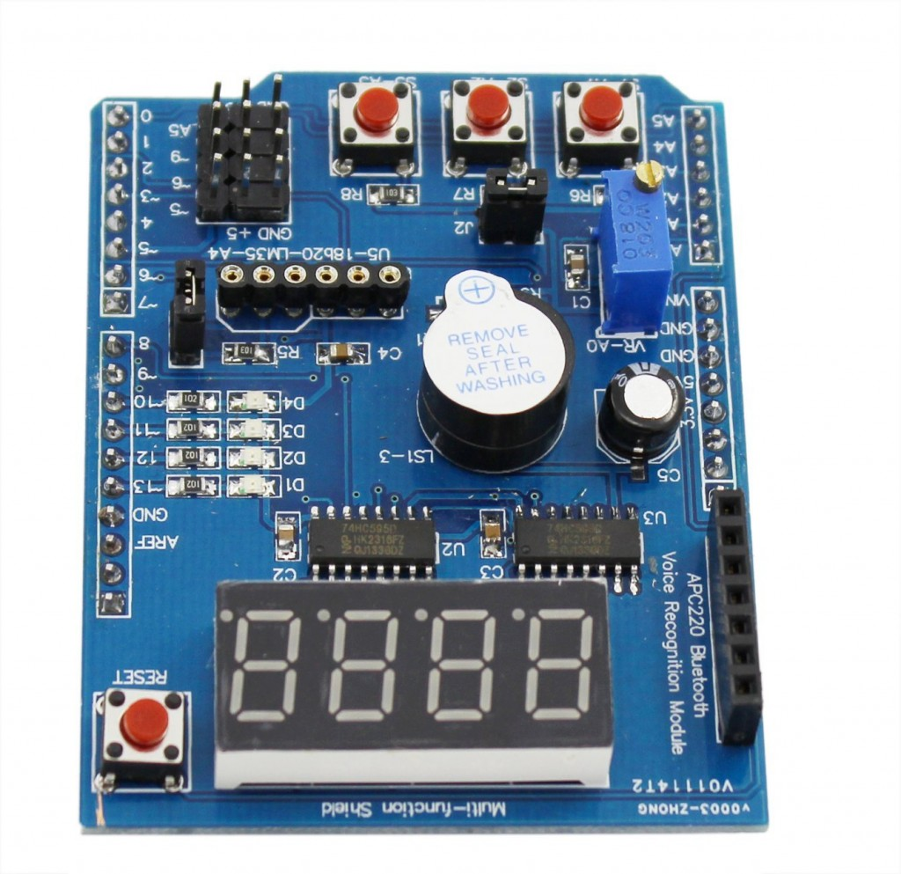

multi function shield

**Features**

4 digit 7-segment LED display module driven by two serial 74HC595’s

4 LED’s

10K potentiometer

3 x push buttons

Piezo buzzer

DS18B20 temperature sensor interface (not included)

Infrared receiver interface

Serial interface header for connection to serial modules

### **Code Examples**

********************************************************************

**Blinking LED**

[?](http://arduinolearning.com/code/multi-function-shield-examples.php#)

| 1  2  3  4  5  6  7  8  9  10  11  12  13  14  15 | int led = 13;    void setup()  {  // initialize the digital pin as an output.  pinMode(led, OUTPUT);  }    void loop()  {  digitalWrite(led, HIGH);  delay(1000);  digitalWrite(led, LOW);  delay(1000);  } |
| --- | --- |

********************************************************************

**All LEDS blinking**

[?](http://arduinolearning.com/code/multi-function-shield-examples.php#)

| 1  2  3  4  5  6  7  8  9  10  11  12  13  14  15  16  17  18  19  20  21  22  23  24  25  26  27 | int led1 = 13;  int led2 = 12;  int led3 = 11;  int led4 = 10;    void setup()  {  // initialize the digital pin as an output.  pinMode(led1, OUTPUT);  pinMode(led2, OUTPUT);  pinMode(led3, OUTPUT);  pinMode(led4, OUTPUT);  }    void loop()  {  digitalWrite(led1, HIGH);  digitalWrite(led2, HIGH);  digitalWrite(led3, HIGH);  digitalWrite(led4, HIGH);  delay(1000);  digitalWrite(led1, LOW);  digitalWrite(led2, LOW);  digitalWrite(led3, LOW);  digitalWrite(led4, LOW);  delay(1000);  } |
| --- | --- |

********************************************************************

**Switches example**

[?](http://arduinolearning.com/code/multi-function-shield-examples.php#)

| 1  2  3  4  5  6  7  8  9  10  11  12  13  14  15  16  17  18  19  20  21  22  23  24  25  26  27  28  29  30  31  32  33 | const byte LED[] = {13,12,11,10};    #define BUTTON1 A1  #define BUTTON2 A2    void setup()  {  // initialize the digital pin as an output.  /* Set each pin to outputs */  pinMode(LED[0], OUTPUT);  pinMode(LED[1], OUTPUT);  pinMode(LED[2], OUTPUT);  pinMode(LED[3], OUTPUT);  }    void loop()  {  if(!digitalRead(BUTTON1))  {  digitalWrite(LED[0], HIGH);  digitalWrite(LED[1], HIGH);  digitalWrite(LED[2], HIGH);  digitalWrite(LED[3], HIGH);  }    if(!digitalRead(BUTTON2))  {  digitalWrite(LED[0], LOW);  digitalWrite(LED[1], LOW);  digitalWrite(LED[2], LOW);  digitalWrite(LED[3], LOW);  }  } |
| --- | --- |

********************************************************************

**Potentiometer 1**

[?](http://arduinolearning.com/code/multi-function-shield-examples.php#)

| 1  2  3  4  5  6  7  8  9  10  11  12  13  14  15  16 | #define Pot1 0    void setup()  {  Serial.begin(9600);  }    /* Main Program */  void loop()  {    Serial.print(“Potentiometer reading: “);  Serial.println(analogRead(Pot1));  /* Wait 0.5 seconds before reading again */  delay(500);  } |
| --- | --- |

********************************************************************

**Pot and led**

[?](http://arduinolearning.com/code/multi-function-shield-examples.php#)

| 1  2  3  4  5  6  7  8  9  10  11  12  13  14  15  16  17  18  19  20  21  22  23  24  25  26  27  28  29  30  31  32  33  34  35  36  37  38  39  40  41 | const byte LED[] = {13,12,11,10};  #define Pot1 0    void setup()  {  Serial.begin(9600);  // initialize the digital pin as an output.  /* Set each pin to outputs */  pinMode(LED[0], OUTPUT);  pinMode(LED[1], OUTPUT);  pinMode(LED[2], OUTPUT);  pinMode(LED[3], OUTPUT);  }    /* Main Program */  void loop()  {  int PotValue;  //Serial.print(“Potentiometer reading: “);  PotValue = analogRead(Pot1);  /* Wait 0.5 seconds before reading again */  if(PotValue < 400)  {  digitalWrite(LED[0], LOW);  digitalWrite(LED[1], LOW);  digitalWrite(LED[2], LOW);  digitalWrite(LED[3], LOW);  Serial.print(“Potentiometer: “);  Serial.println(PotValue);  }  else  {  digitalWrite(LED[0], HIGH);  digitalWrite(LED[1], HIGH);  digitalWrite(LED[2], HIGH);  digitalWrite(LED[3], HIGH);  Serial.print(“Potentiometer: “);  Serial.println(PotValue);  }  delay(500);  } |
| --- | --- |

********************************************************************

**segment display**

[?](http://arduinolearning.com/code/multi-function-shield-examples.php#)

| 1  2  3  4  5  6  7  8  9  10  11  12  13  14  15  16  17  18  19  20  21  22  23  24  25  26  27  28  29  30  31  32  33  34  35  36  37 | /* Define shift register pins used for seven segment display */  #define LATCH_DIO 4  #define CLK_DIO 7  #define DATA_DIO 8    /* Segment byte maps for numbers 0 to 9 */  const byte SEGMENT_MAP[] = {0xC0,0xF9,0xA4,0xB0,0x99,0x92,0x82,0xF8,0X80,0X90};  /* Byte maps to select digit 1 to 4 */  const byte SEGMENT_SELECT[] = {0xF1,0xF2,0xF4,0xF8};    void setup ()  {  /* Set DIO pins to outputs */  pinMode(LATCH_DIO,OUTPUT);  pinMode(CLK_DIO,OUTPUT);  pinMode(DATA_DIO,OUTPUT);  }    /* Main program */  void loop()  {    /* Update the display with the current counter value */  WriteNumberToSegment(0 , 0);  WriteNumberToSegment(1 , 1);  WriteNumberToSegment(2 , 2);  WriteNumberToSegment(3 , 3);  }    /* Write a decimal number between 0 and 9 to one of the 4 digits of the display */  void WriteNumberToSegment(byte Segment, byte Value)  {  digitalWrite(LATCH_DIO,LOW);  shiftOut(DATA_DIO, CLK_DIO, MSBFIRST, SEGMENT_MAP[Value]);  shiftOut(DATA_DIO, CLK_DIO, MSBFIRST, SEGMENT_SELECT[Segment] );  digitalWrite(LATCH_DIO,HIGH);  } |
| --- | --- |

********************************************************************

**Read pot and display value on display**

[?](http://arduinolearning.com/code/multi-function-shield-examples.php#)

| 1  2  3  4  5  6  7  8  9  10  11  12  13  14  15  16  17  18  19  20  21  22  23  24  25  26  27  28  29  30  31  32  33  34  35  36  37  38  39  40  41  42  43 | /* Define shift register pins used for seven segment display */  #define LATCH_DIO 4  #define CLK_DIO 7  #define DATA_DIO 8    #define Pot1 0    /* Segment byte maps for numbers 0 to 9 */  const byte SEGMENT_MAP[] = {0xC0,0xF9,0xA4,0xB0,0x99,0x92,0x82,0xF8,0X80,0X90};  /* Byte maps to select digit 1 to 4 */  const byte SEGMENT_SELECT[] = {0xF1,0xF2,0xF4,0xF8};    void setup ()  {  Serial.begin(9600);  /* Set DIO pins to outputs */  pinMode(LATCH_DIO,OUTPUT);  pinMode(CLK_DIO,OUTPUT);  pinMode(DATA_DIO,OUTPUT);  }    /* Main program */  void loop()  {  int PotValue;  PotValue = analogRead(Pot1);  Serial.print(“Potentiometer: “);  Serial.println(PotValue);  /* Update the display with the current counter value */  WriteNumberToSegment(0 , PotValue / 1000);  WriteNumberToSegment(1 , (PotValue / 100) % 10);  WriteNumberToSegment(2 , (PotValue / 10) % 10);  WriteNumberToSegment(3 , PotValue % 10);  }    /* Write a decimal number between 0 and 9 to one of the 4 digits of the display */  void WriteNumberToSegment(byte Segment, byte Value)  {  digitalWrite(LATCH_DIO,LOW);  shiftOut(DATA_DIO, CLK_DIO, MSBFIRST, SEGMENT_MAP[Value]);  shiftOut(DATA_DIO, CLK_DIO, MSBFIRST, SEGMENT_SELECT[Segment] );  digitalWrite(LATCH_DIO,HIGH);  } |
| --- | --- |

********************************************************************

**Resources**

**[Multifunctional Expansion Board Shield Kit](http://amzn.to/1v7w9I8)**